DBMS PROJECT – WEEK 1
E-Commerce Database Management System
1. Introduction
An e-commerce system manages the end-to-end flow of buying, selling, and managing products online. The project focuses on designing a database structure for an e-commerce platform and identifying the data required for customers, sellers, products, orders, payments, and reviews.
The database helps to organize and manage information efficiently and supports different activities such as product searching, ordering, payment processing, delivery, and customer reviews.

2. Objectives
- To understand the business process of an e-commerce system.
- To identify the main entities and their attributes.
- To define primary keys and foreign-key relationships.
- To organize customer, seller, product, order, payment, and review information.
- To implement the database using SQL commands in an Oracle SQL environment.

3. Requirement Analysis
The business process described in the project follows these major stages:
- Browse / Search Product – The customer searches for the product they want to purchase.
- Add to Cart – The selected product is added to the cart.
- Order Placed – The customer selects the delivery address and places the order.
- Checkout / Payment – The customer moves to the payment and checkout process.
- Delivery – After payment, the product is assigned to the seller for dispatch and delivery.
- Review & Support – After successful delivery, the customer may review the product and may require support for installation, return, or replacement.
Process Flow
Browse / Search Product
↓
Add to Cart
↓
Order Placed
↓
Checkout / Payment
↓
Delivery
↓
Review & Support

4. Entities and Attributes
Entity | Important Attributes | Key | Relationship
Customer | customer_id, first_name, last_name, email, phone, created_at | customer_id (PK) | One-to-Many with Order and Review
Seller | seller_id, company_name, email, phone, rating, bank_details | seller_id (PK) | One-to-Many with Product
Product | product_id, seller_id, title, description, price, stock_quantity, sku, category | product_id (PK), seller_id (FK) | Many-to-One with Seller; One-to-Many with Review
Order | order_id, customer_id, order_date, status, total_amount, shipping_address | order_id (PK), customer_id (FK) | Many-to-One with Customer; One-to-One with Payment; Many-to-Many with Product via OrderItem
Payment | payment_id, order_id, payment_method, status, transaction_id, amount, payment_date | payment_id (PK), order_id (FK) | One-to-One with Order
Review | review_id, customer_id, product_id, rating, comment, created_at | review_id (PK), customer_id (FK), product_id (FK) | Many-to-One with Customer and Product
The entity definitions and relationships follow the structure in the provided Week 1 document.

5. Database Design
The Customer entity stores information about end users who browse and purchase products. The Seller entity represents merchants or vendors. Products are linked to sellers. Orders are linked to customers, while payments are tied to orders. Reviews connect customers with products.
The database design uses primary keys to uniquely identify records and foreign keys to establish relationships between tables.

6. Customer Table
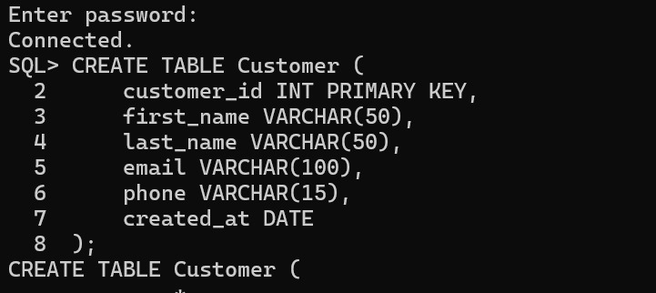

Insert Values
